Supporting information
Contents:
- Supplementary Table 1…………………………………………………………….1
- Supplementary Table 2…………………………………………………………….2
- Spectra of synthesized compounds………………………………..……...…….3-29

Supplementary Table 1. Docking results of target compounds with HDAC6
Comp. | S | RMSD | E_conf | E_place | E_refine
3a | -8.0963 | 1.7909 | 54.1805 | -56.3339 | -63.4331
3b | -8.7172 | 1.2936 | 90.3886 | -63.4945 | -70.9384
3c | -8.6817 | 1.5994 | 59.4313 | -67.4028 | -68.9211
3d | -8.4230 | 1.4729 | 55.2752 | -52.8484 | -67.2561
3e | -8.4275 | 2.6858 | 48.4488 | -91.4097 | -67.2908
3f | -8.4986 | 1.6473 | 51.2126 | -55.1749 | -67.0357
3g | -8.2827 | 1.3537 | 39.1390 | -83.7832 | -64.3515
3h | -8.0448 | 1.5047 | 57.1272 | -114.1694 | -63.6582
3i | -8.3351 | 1.5839 | 33.6477 | -64.7066 | -66.8058
3j | -8.5709 | 2.0628 | 54.2977 | -61.9882 | -67.9447
3k | -8.4643 | 1.2455 | 49.3859 | -92.4938 | -67.8140
3l | -8.0979 | 1.4756 | 49.8230 | -79.3251 | -64.0462
3m | -8.8628 | 0.8520 | 58.7624 | -115.9744 | -69.5445
3n | -8.9528 | 1.0047 | 51.8938 | -122.9536 | -69.5773
3o | -9.2598 | 1.0312 | 48.4677 | -56.4729 | -73.3196
3p | -9.0782 | 1.2104 | 47.5976 | -54.8303 | -68.1838
3q | -8.5290 | 1.1458 | 54.4952 | -83.8445 | -67.5513
3r | -9.2043 | 1.2867 | -4.8706 | -98.5310 | -68.9350
3s | -9.0873 | 1.8957 | 27.6597 | -41.8125 | -72.3099
3t | -8.5859 | 0.8916 | 58.0640 | -87.6725 | -67.6199
3u | -8.3969 | 1.5726 | 44.2954 | -80.6797 | -66.3413
3v | -8.5246 | 1.3786 | 42.2977 | -75.8482 | -67.1335
3w | -8.5534 | 1.0902 | 42.5482 | -74.0678 | -67.7378
Ligand | -9.9527 | 0.5414 | 46.3983 | -91.886 | -77.8827
Note: S: socre, kcal/mol; RMSD: root mean square deviation values represents the root mean square deviation between the docked ligand and co-crystalline ligand. Ligand: the ligand of PDB (6PYE).

Supplementary Table 2. Docking results of target compounds with HDAC1
Comp. | S | RMSD | E_conf | E_place | E_refine
3a | -7.7840 | 0.9366 | 54.2361 | -96.1721 | -59.9422
3b | -8.0087 | 1.5005 | 88.7257 | -64.2670 | -62.2285
3c | -8.4054 | 1.7405 | 62.0242 | -73.6104 | -65.2075
3d | -7.7629 | 1.5687 | 53.9936 | -68.5226 | -59.4098
3e | -7.8371 | 1.4006 | 50.2437 | -91.7559 | -60.2972
3f | -7.9046 | 1.3142 | 54.7425 | -87.2421 | -61.3767
3g | -7.9597 | 1.9226 | 40.8167 | -76.7244 | -61.5248
3h | -7.9424 | 1.4937 | 57.2104 | -52.1035 | -60.7248
3i | -7.8957 | 1.3931 | 32.1801 | -93.5918 | -61.0186
3j | -8.0680 | 1.6593 | 50.0493 | -70.6723 | -61.9309
3k | -7.9031 | 1.6892 | 52.6287 | -62.5827 | -60.9715
3l | -7.8536 | 1.6595 | 48.0879 | -57.8569 | -59.73150
3m | -8.4591 | 1.1110 | 57.5454 | -85.3772 | -66.3381
3n | -8.5661 | 1.8989 | 53.6370 | -39.7427 | -66.4600
3o | -8.2671 | 3.2538 | 47.8511 | -57.0644 | -63.9721
3p | -8.3521 | 0.9414 | 41.1043 | -120.6852 | -64.9337
3q | -8.3206 | 1.3488 | 51.9066 | -61.0438 | -63.8875
3r | -7.9279 | 1.4468 | -3.3827 | -67.8528 | -58.6646
3s | -8.1328 | 1.1937 | 25.6145 | -95.0293 | -63.2162
3t | -8.2516 | 1.4279 | 55.4690 | -87.8841 | -63.9582
3u | -7.3849 | 1.7306 | 49.9236 | -66.7362 | -51.7278
3v | -7.8828 | 1.3940 | 46.7917 | -56.2391 | -57.9900
3w | -7.9373 | 1.3504 | 44.1688 | -107.2991 | -61.1252
Note: S: socre, kcal/mol; RMSD: root mean square deviation values represents the root mean square deviation between the docked ligand and co-crystalline ligand. PDB:4BKX.

3 Spectra of synthesized compounds:
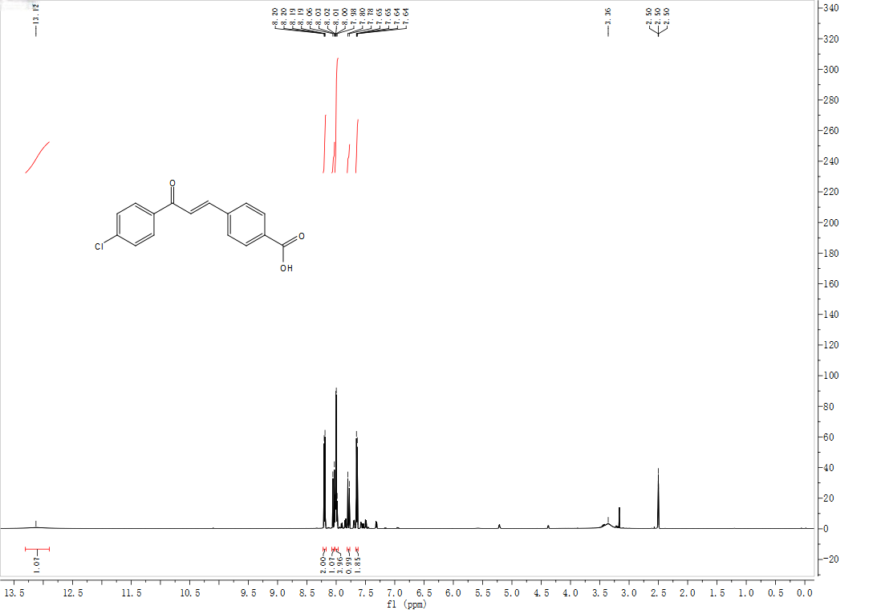
¹H NMR (600 MHz, DMSO-d₆) spectra of 1d
¹H NMR (600 MHz, DMSO-d₆) spectra of 1q
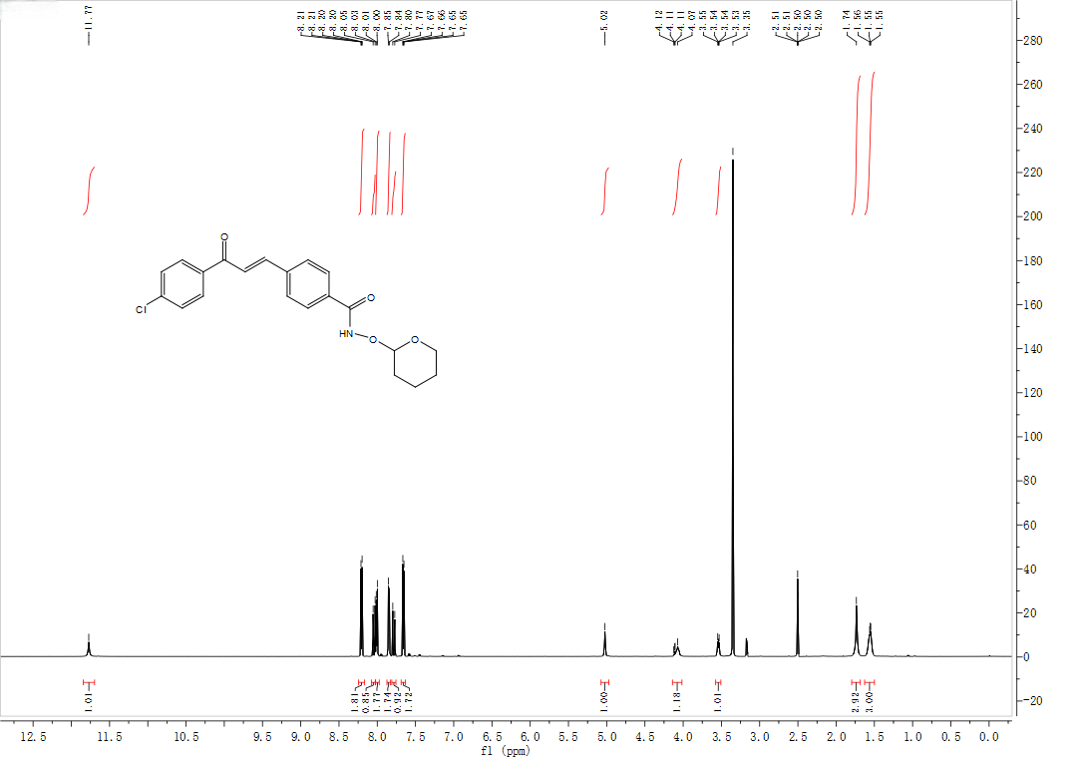
¹H NMR (600 MHz, DMSO-d₆) spectra of 2d
¹H NMR (600 MHz, DMSO-d₆) spectra of 2q
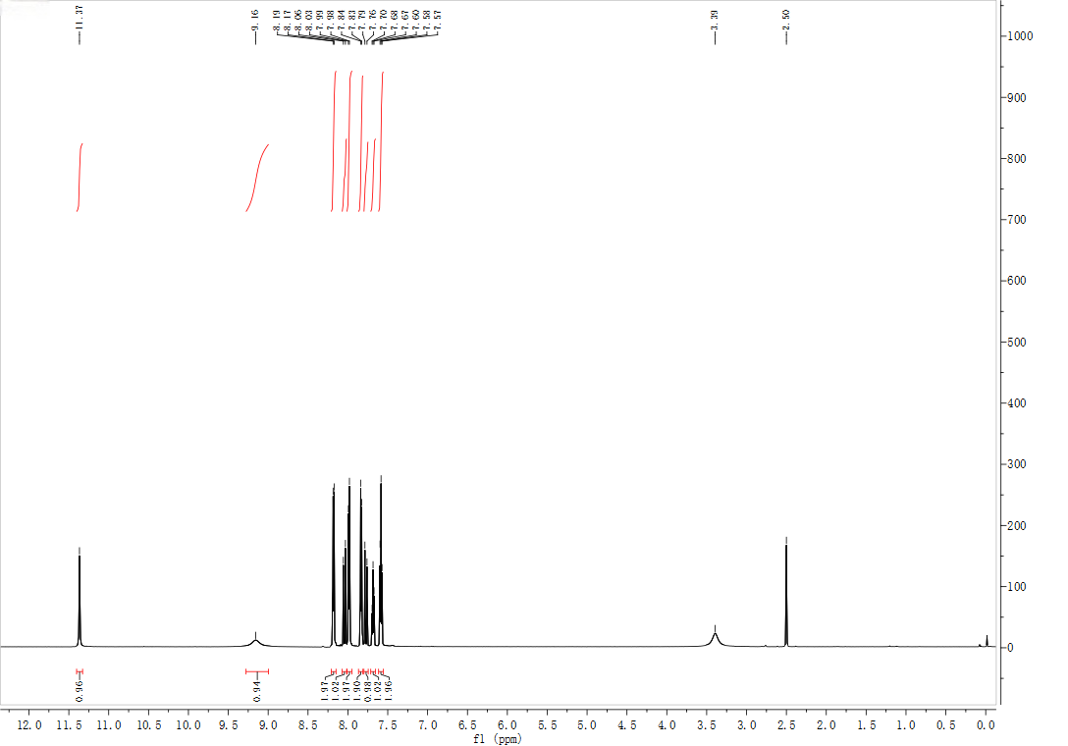
¹H NMR (600 MHz, DMSO-d₆) spectra of 3a
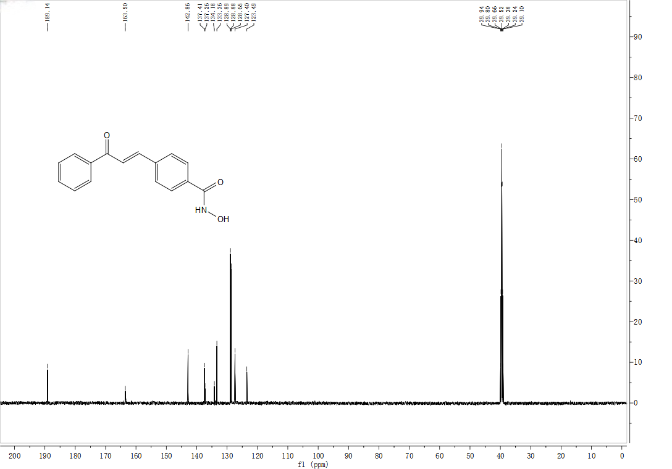
¹³C NMR (151 MHz, DMSO-d₆) spectra of 3a
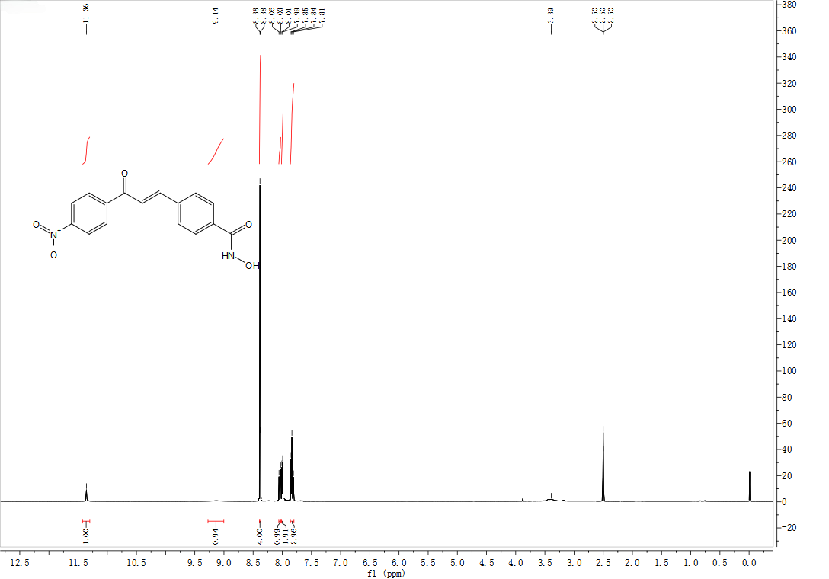
¹H NMR (600 MHz, DMSO-d₆) spectra of 3b
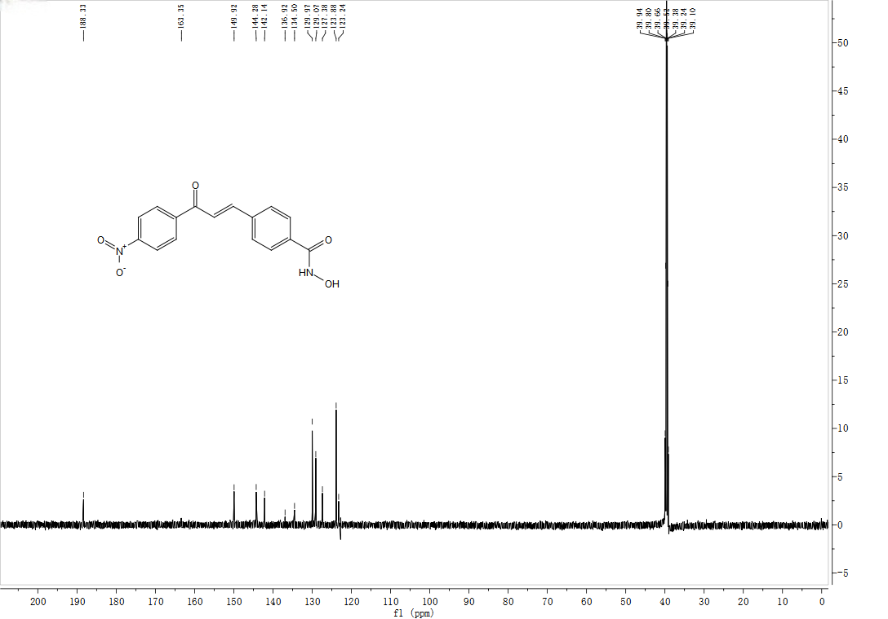
¹³C NMR (151 MHz, DMSO-d₆) spectra of 3b

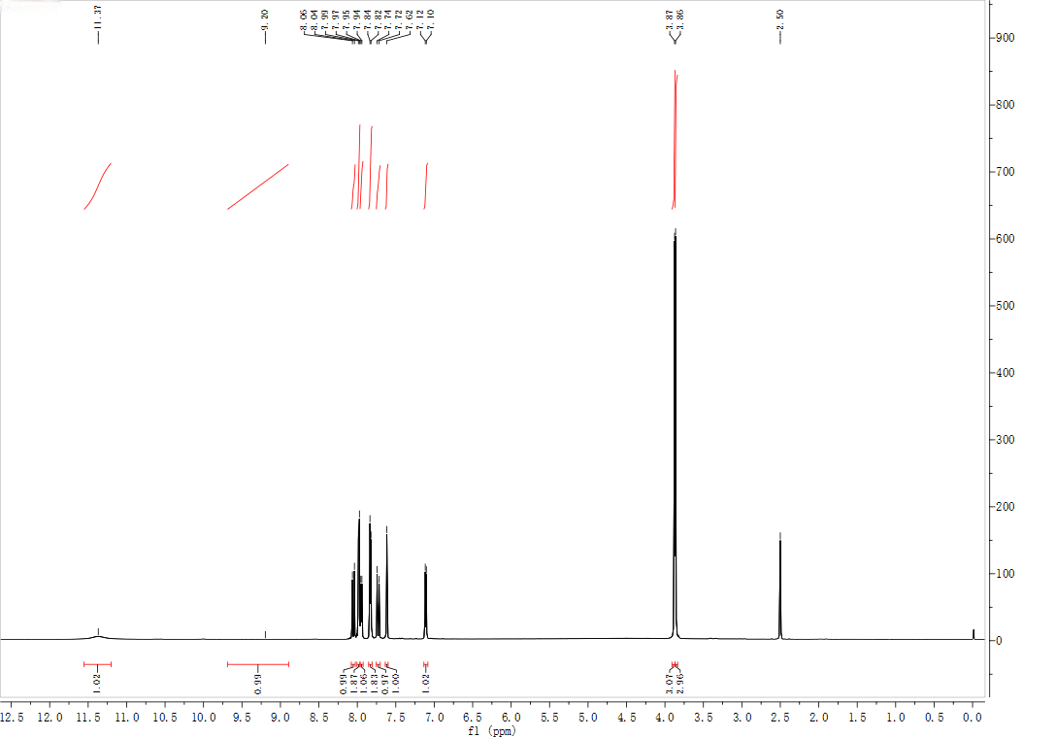
¹H NMR (600 MHz, DMSO-d₆) spectra of 3c
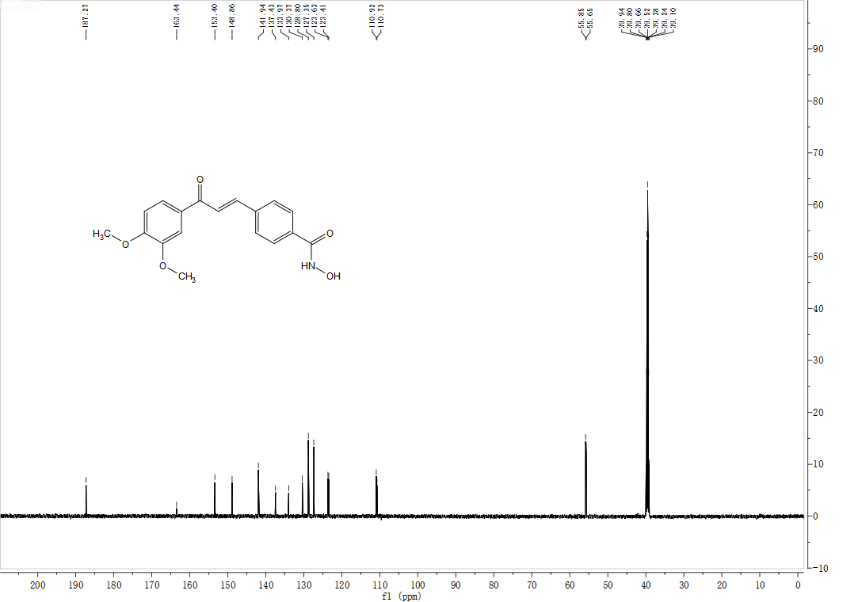
¹³C NMR (151 MHz, DMSO-d₆) spectra of 3c

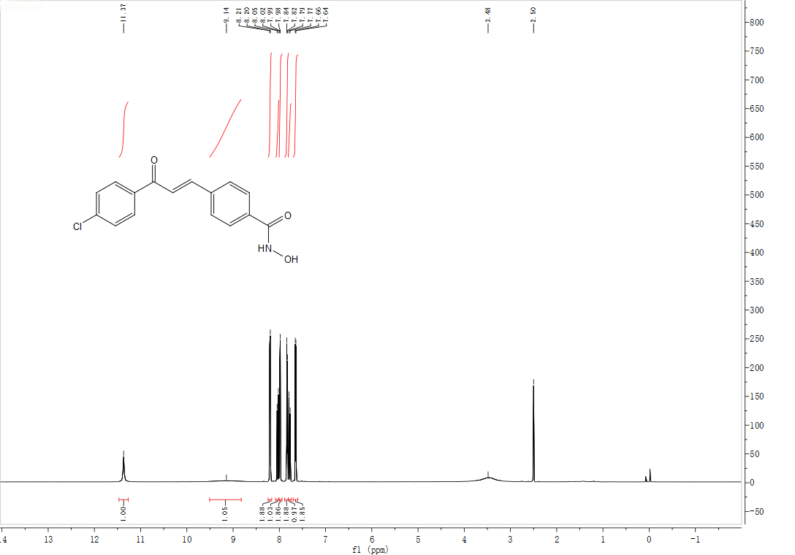
¹H NMR (600 MHz, DMSO-d₆) spectra of 3d
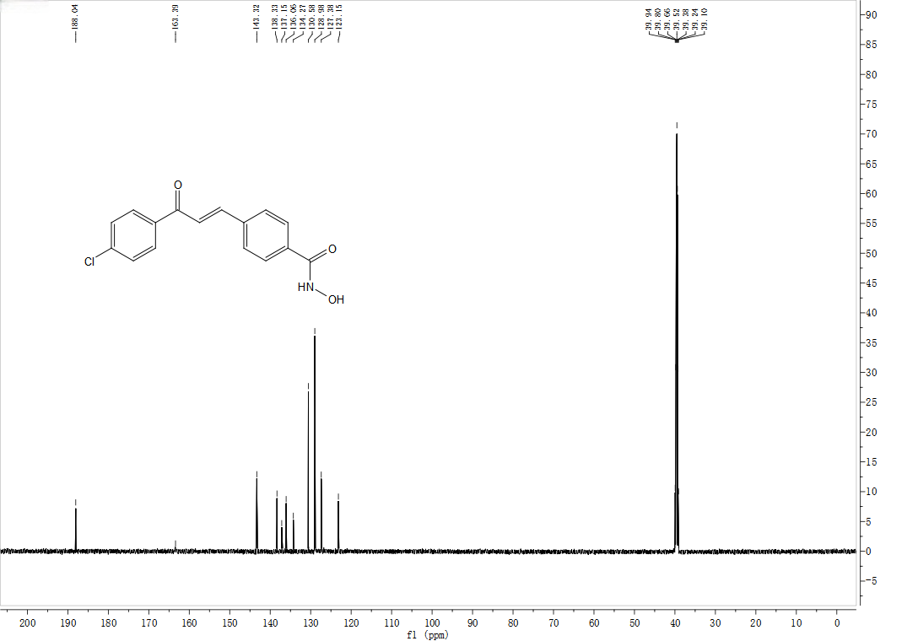
¹³C NMR (151 MHz, DMSO-d₆) spectra of 3d

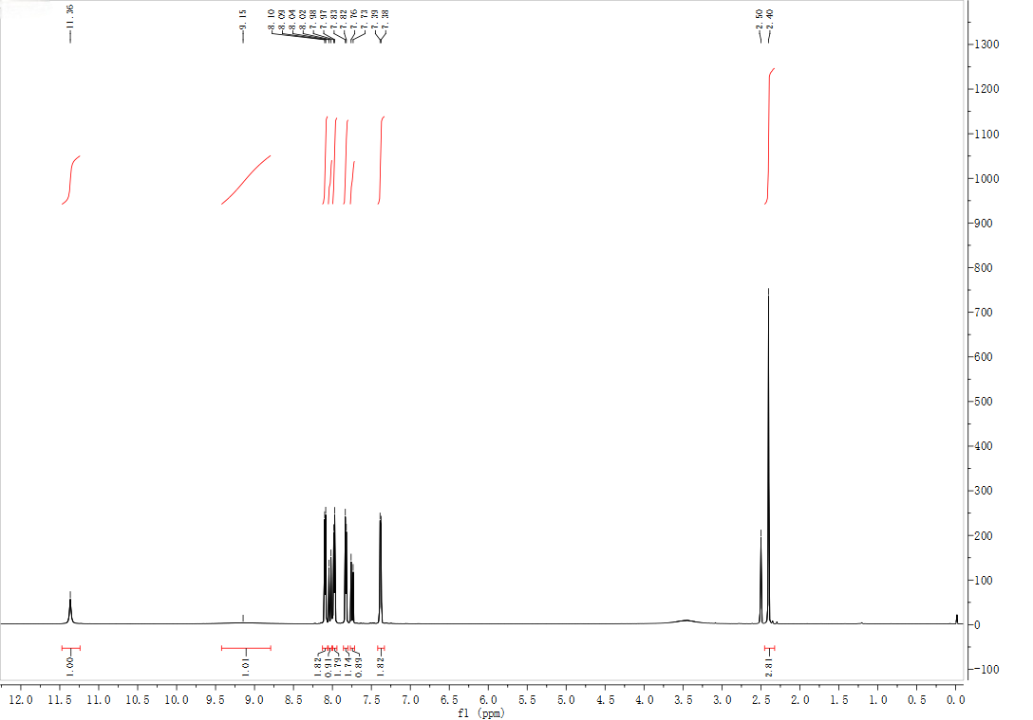
¹H NMR (600 MHz, DMSO-d₆) spectra of 3e
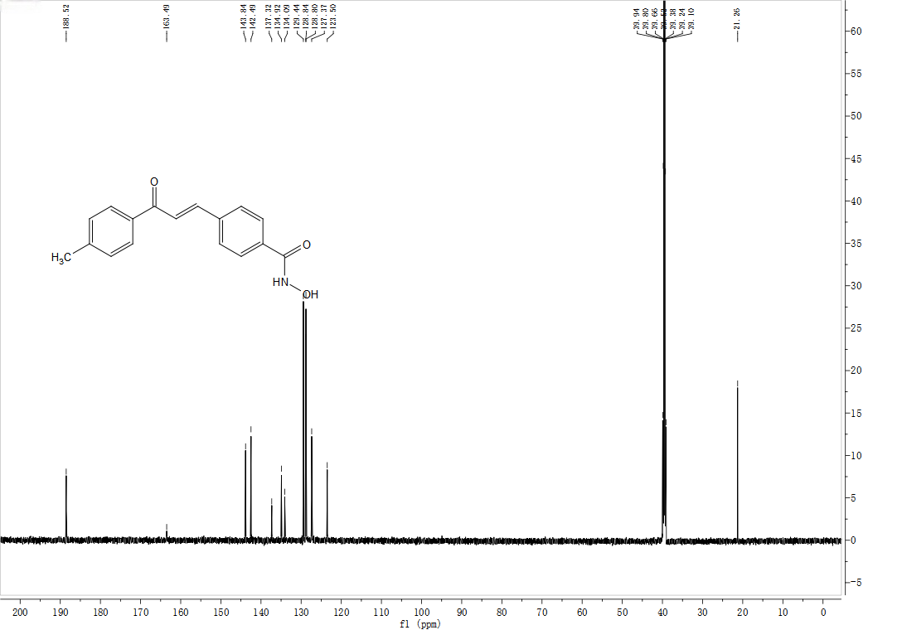
¹³C NMR (151 MHz, DMSO-d₆) spectra of 3e

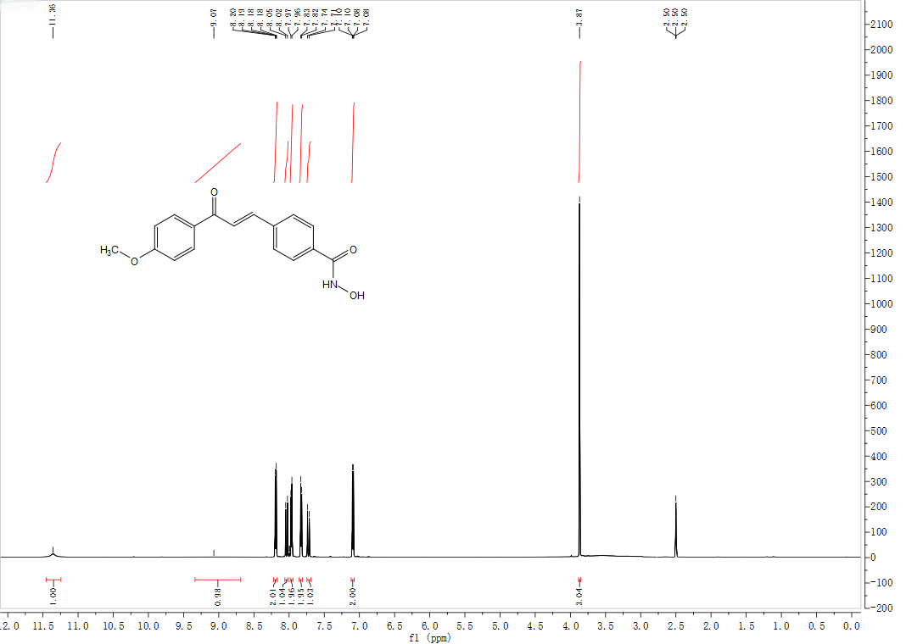
¹H NMR (600 MHz, DMSO-d₆) spectra of 3f
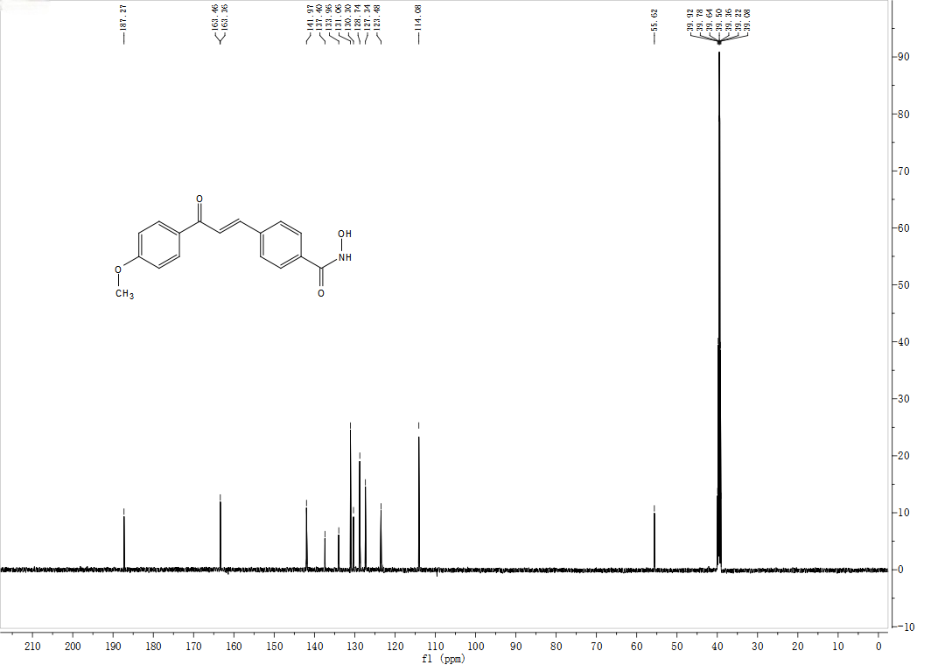
¹³C NMR (151 MHz, DMSO-d₆) spectra of 3f

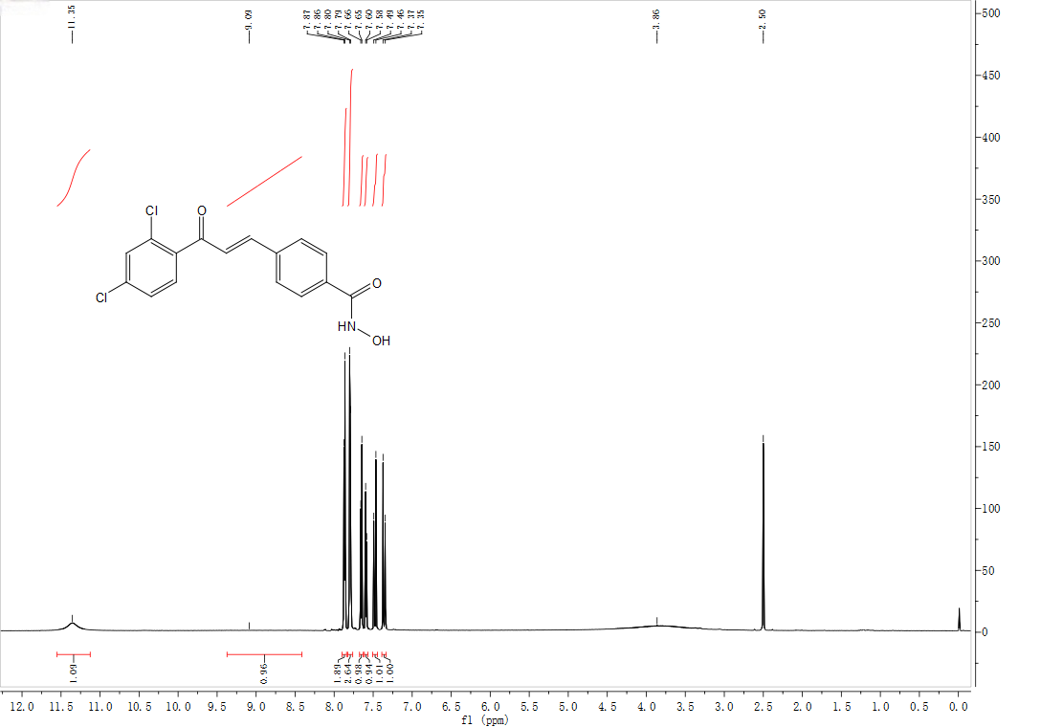
¹H NMR (600 MHz, DMSO-d₆) spectra of 3g
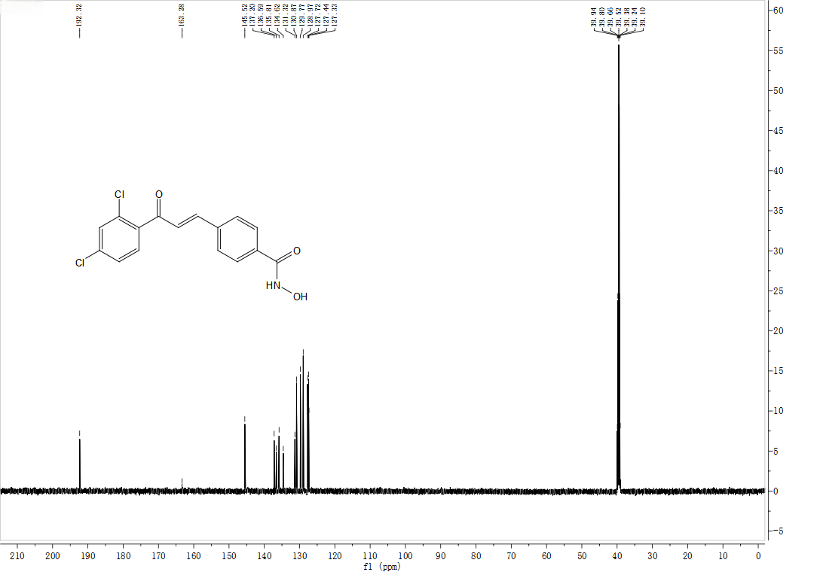
¹³C NMR (151 MHz, DMSO-d₆) spectra of 3g

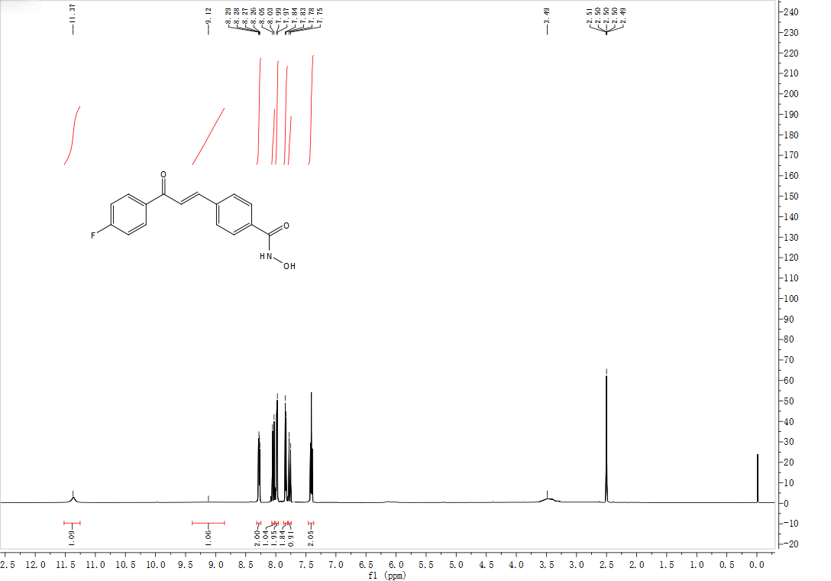
¹H NMR (600 MHz, DMSO-d₆) spectra of 3h
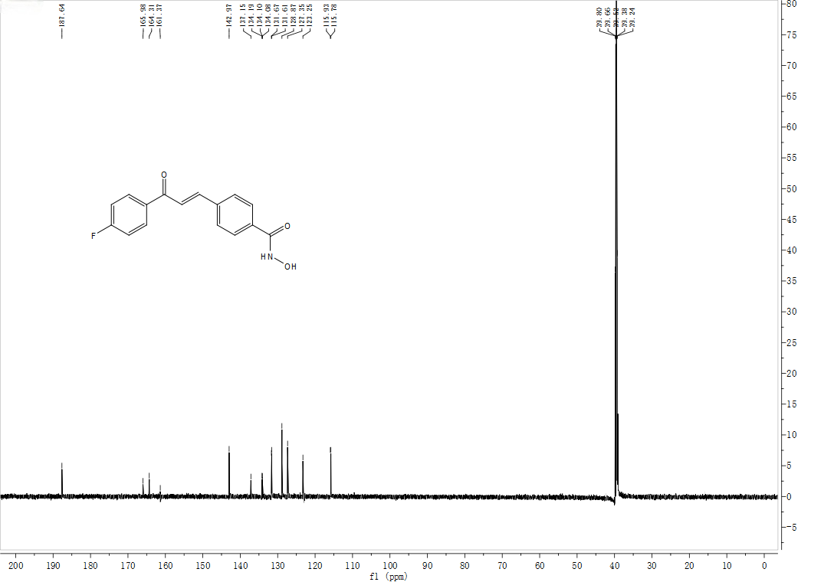
¹³C NMR (151 MHz, DMSO-d₆) spectra of 3h

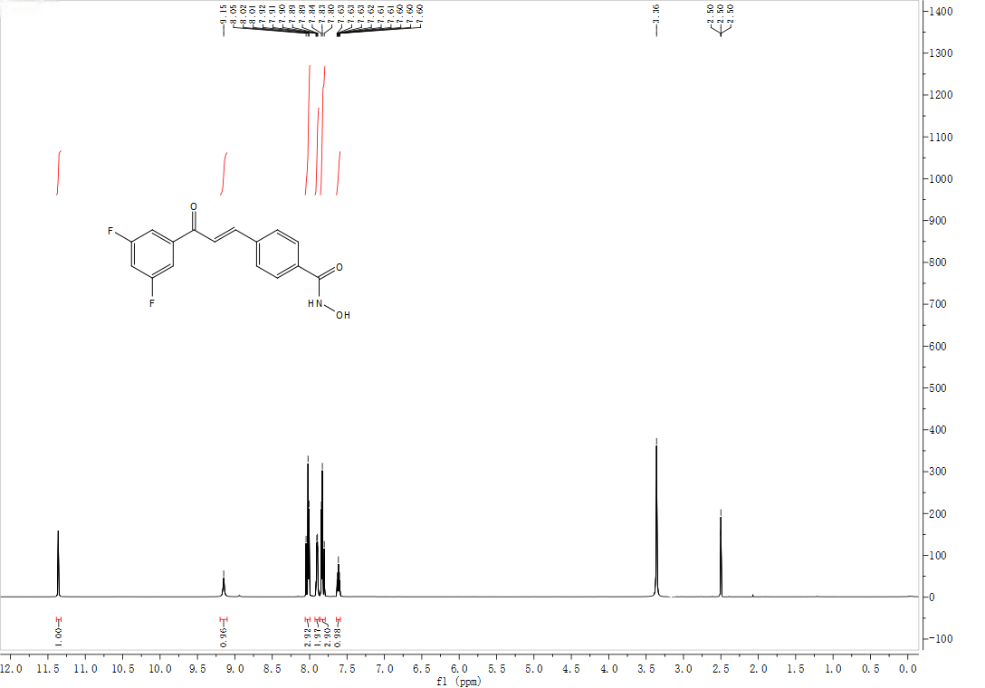
¹H NMR (600 MHz, DMSO-d₆) spectra of 3i
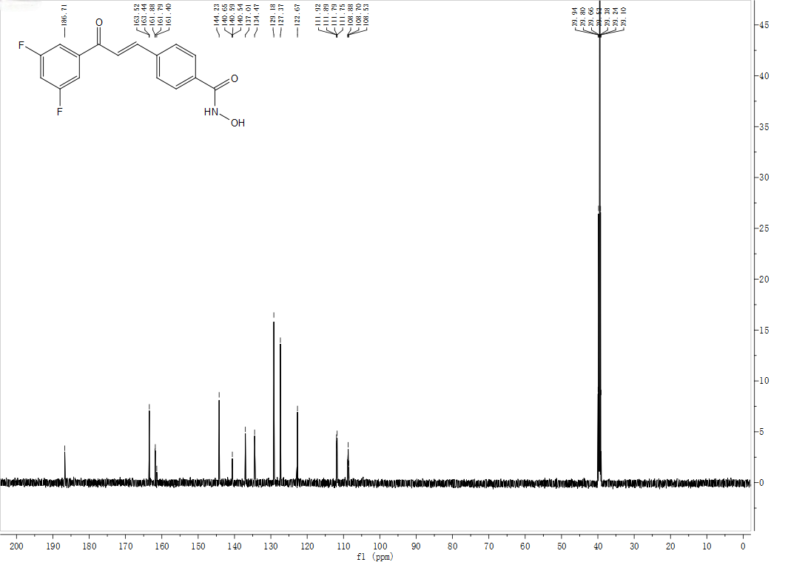
¹³C NMR (151 MHz, DMSO-d₆) spectra of 3i

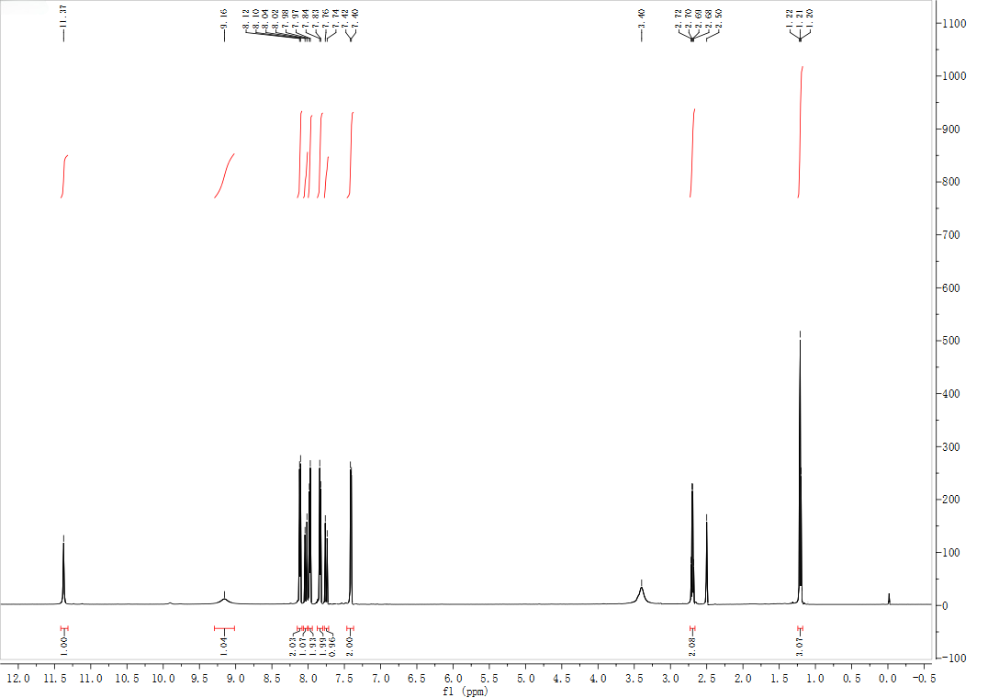
¹H NMR (600 MHz, DMSO-d₆) spectra of 3j
¹³C NMR (151 MHz, DMSO-d₆) spectra of 3j

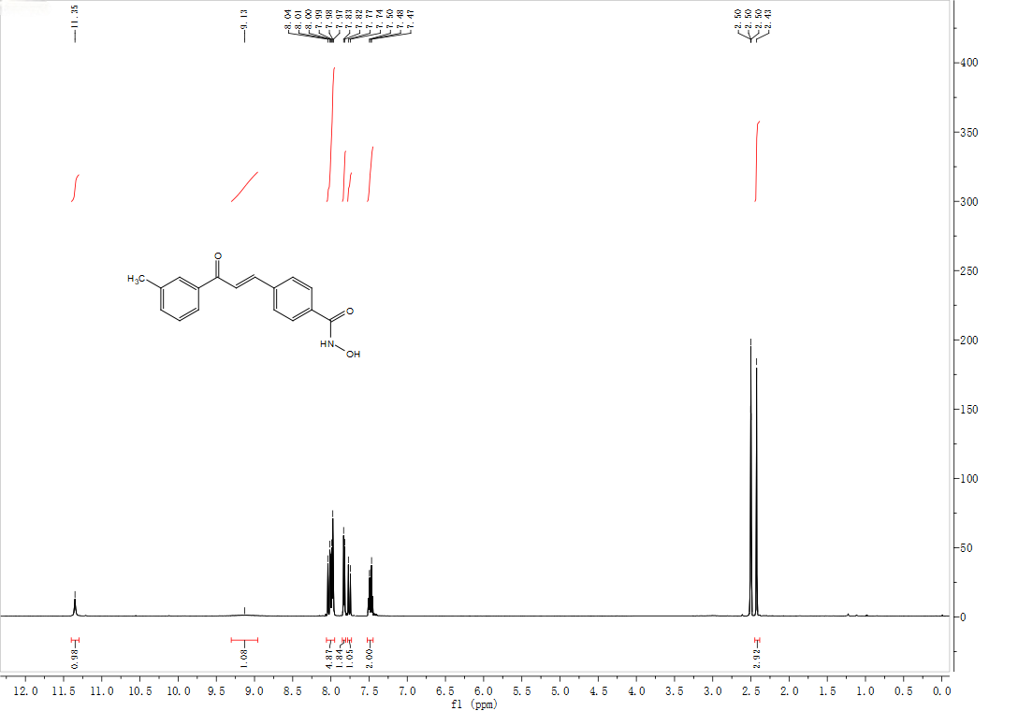
¹H NMR (600 MHz, DMSO-d₆) spectra of 3k
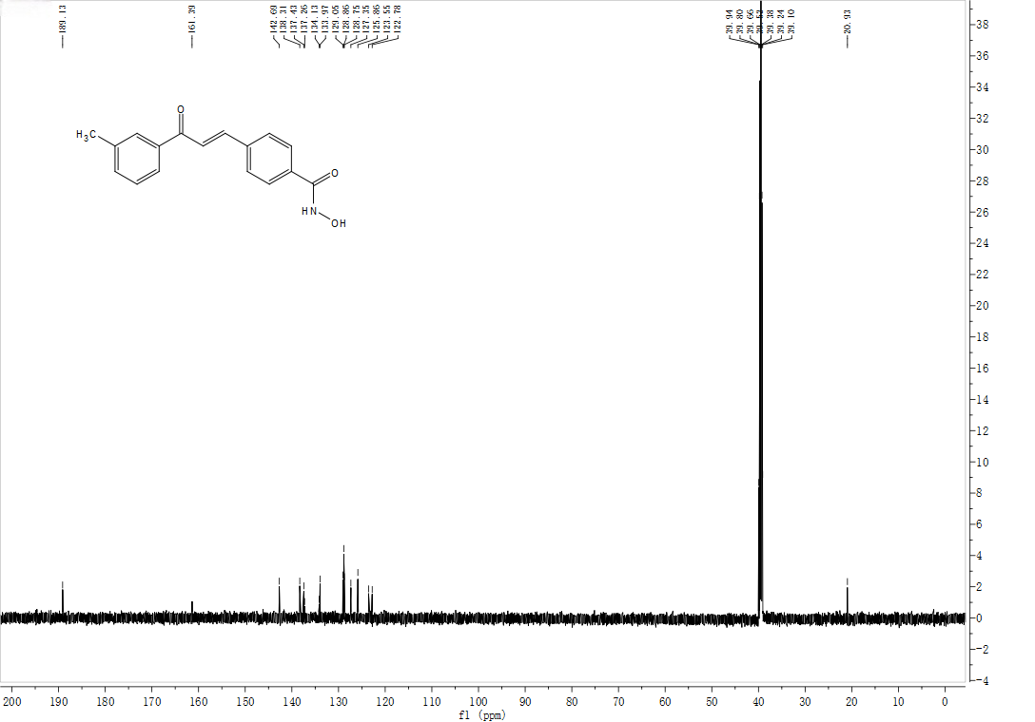
¹³C NMR (151 MHz, DMSO-d₆) spectra of 3k

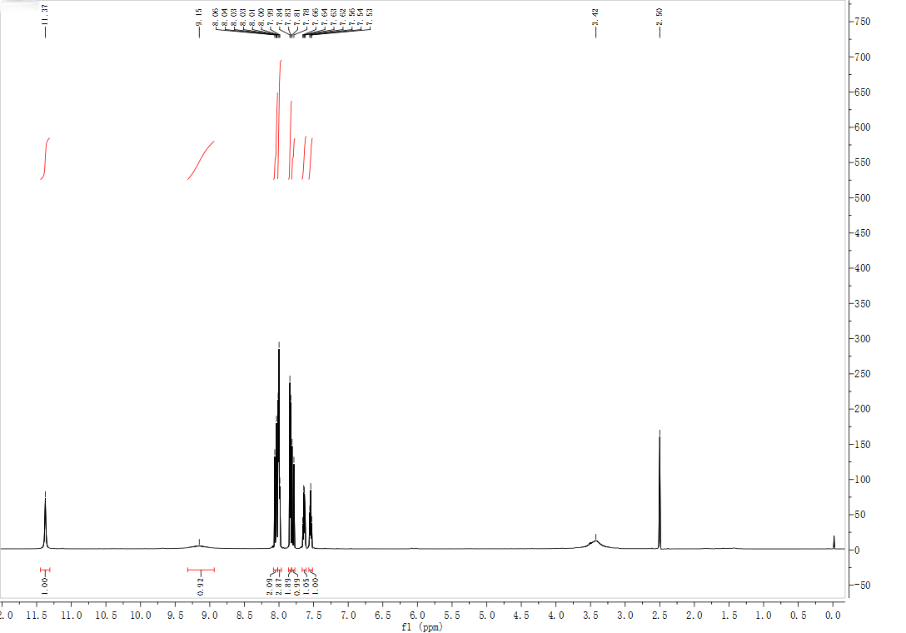
¹H NMR (600 MHz, DMSO-d₆) spectra of 3l
¹³C NMR (151 MHz, DMSO-d₆) spectra of 3l

¹H NMR (600 MHz, DMSO-d₆) spectra of 3m
¹³C NMR (151 MHz, DMSO-d₆) spectra of 3m

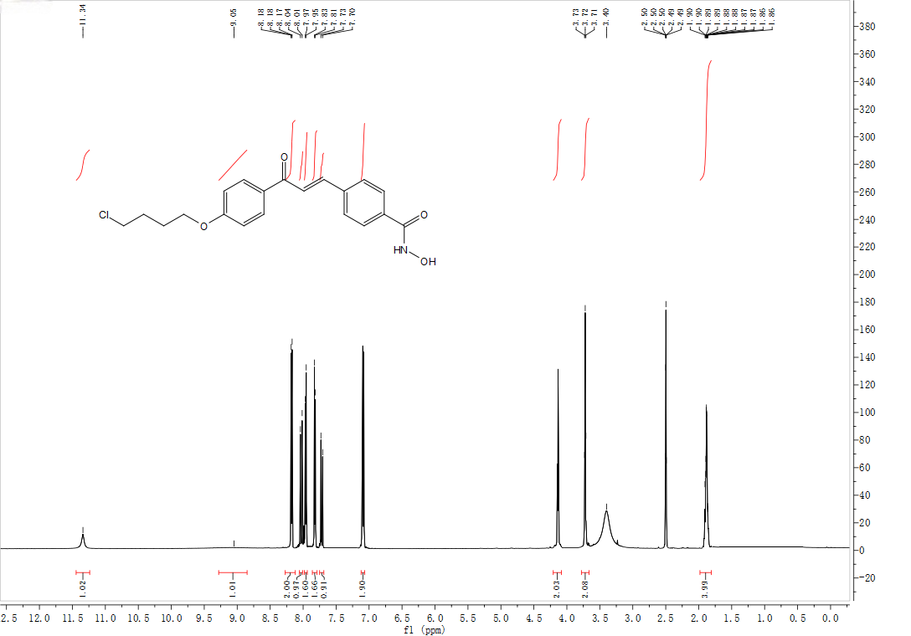
¹H NMR (600 MHz, DMSO-d₆) spectra of 3n
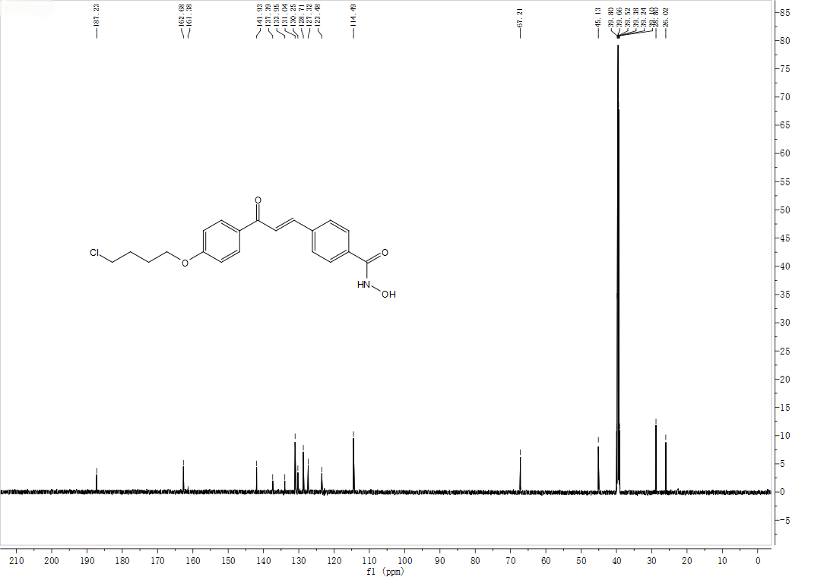
¹³C NMR (151 MHz, DMSO-d₆) spectra of 3n

¹H NMR (600 MHz, DMSO-d₆) spectra of 3o
¹³C NMR (151 MHz, DMSO-d₆) spectra of 3o

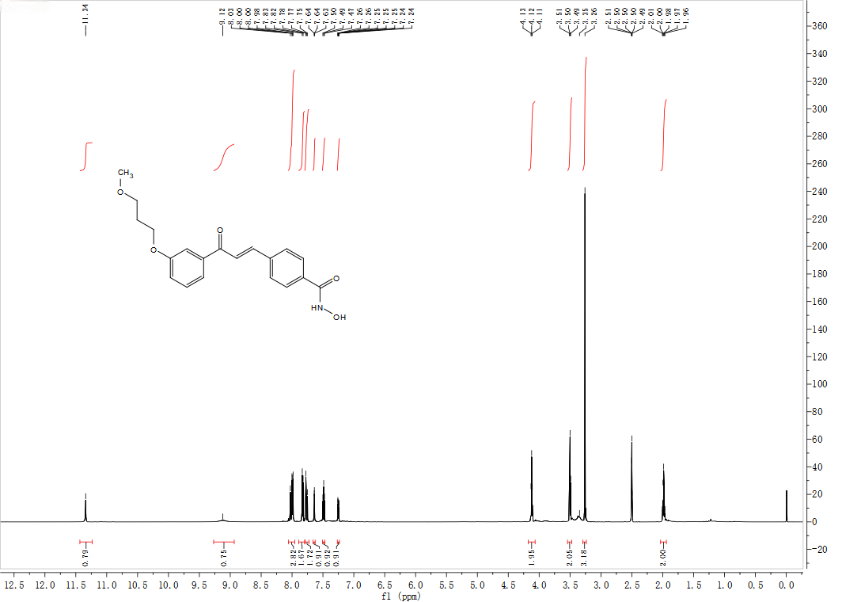
¹H NMR (600 MHz, DMSO-d₆) spectra of 3p
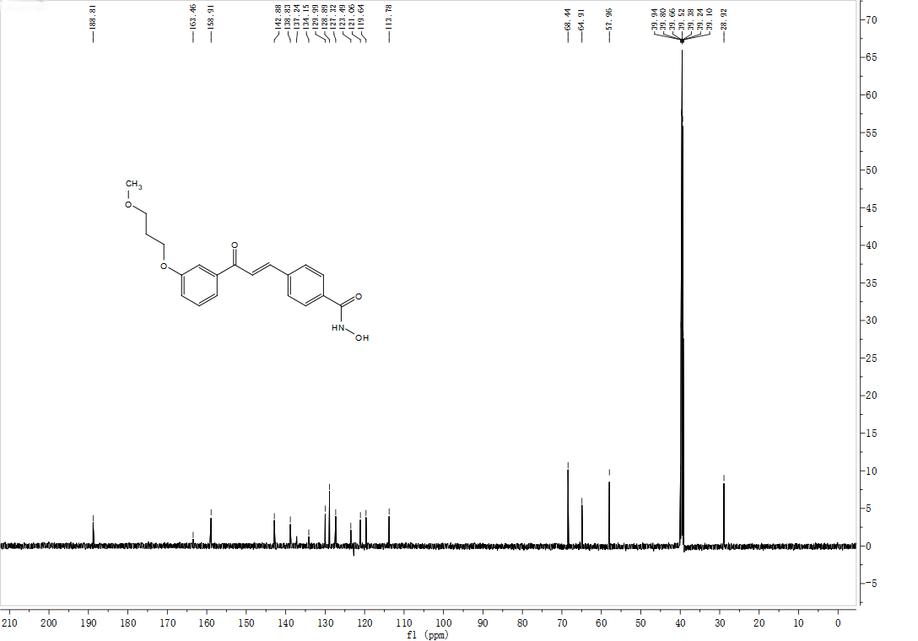
¹³C NMR (151 MHz, DMSO-d₆) spectra of 3p
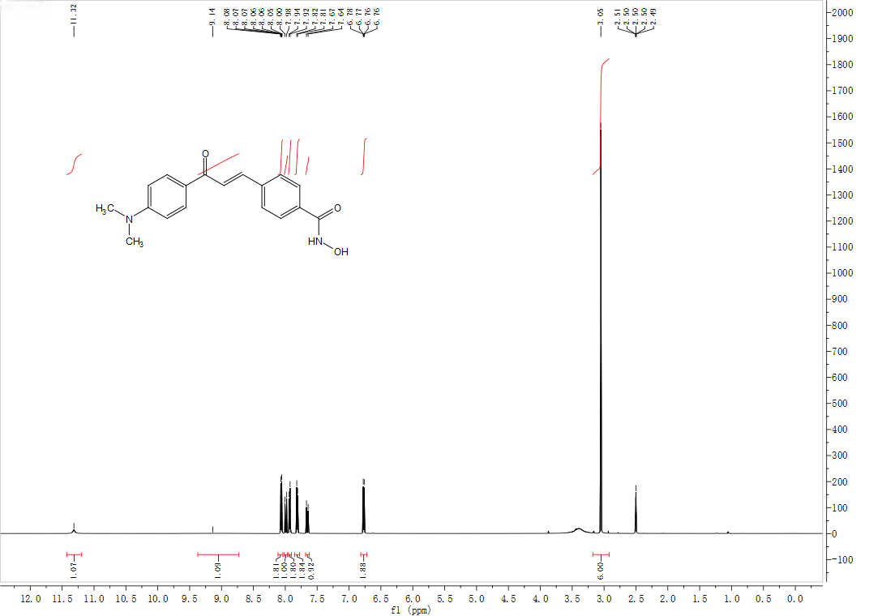
¹H NMR (600 MHz, DMSO-d₆) spectra of 3q
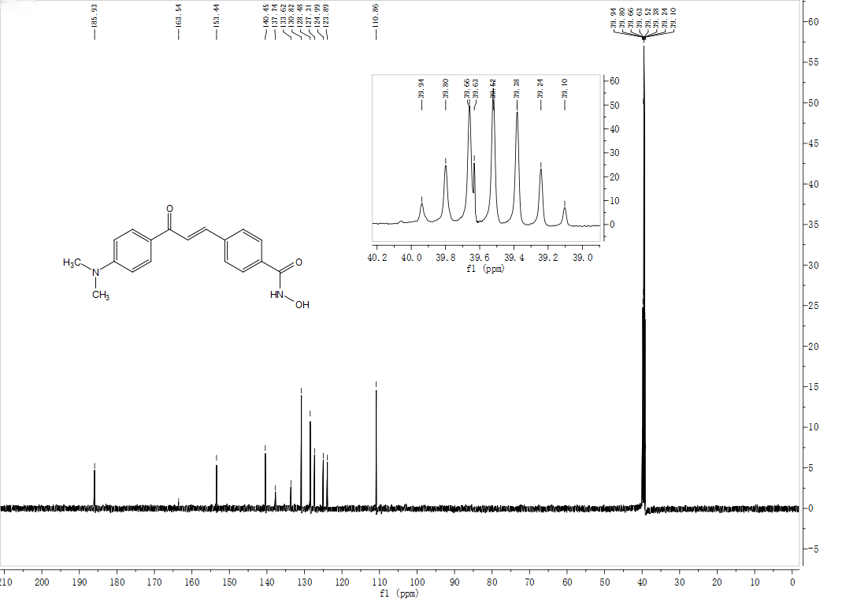
¹³C NMR (151 MHz, DMSO-d₆) spectra of 3q

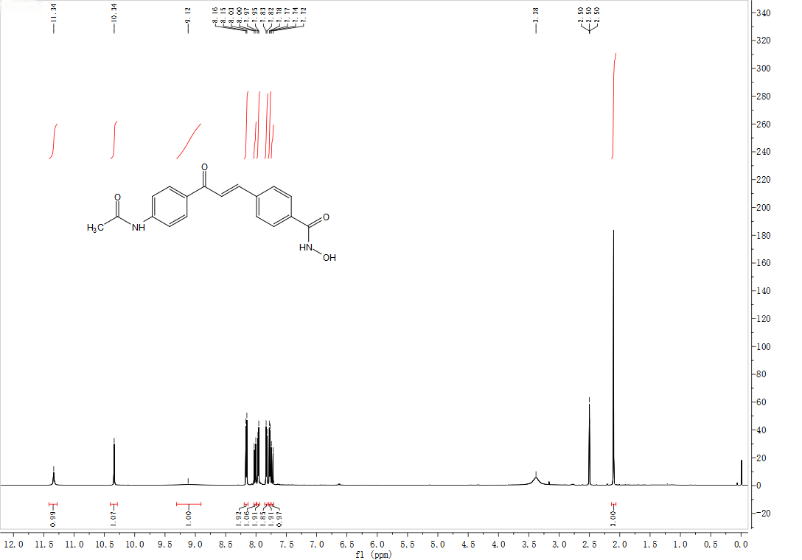
¹H NMR (600 MHz, DMSO-d₆) spectra of 3r
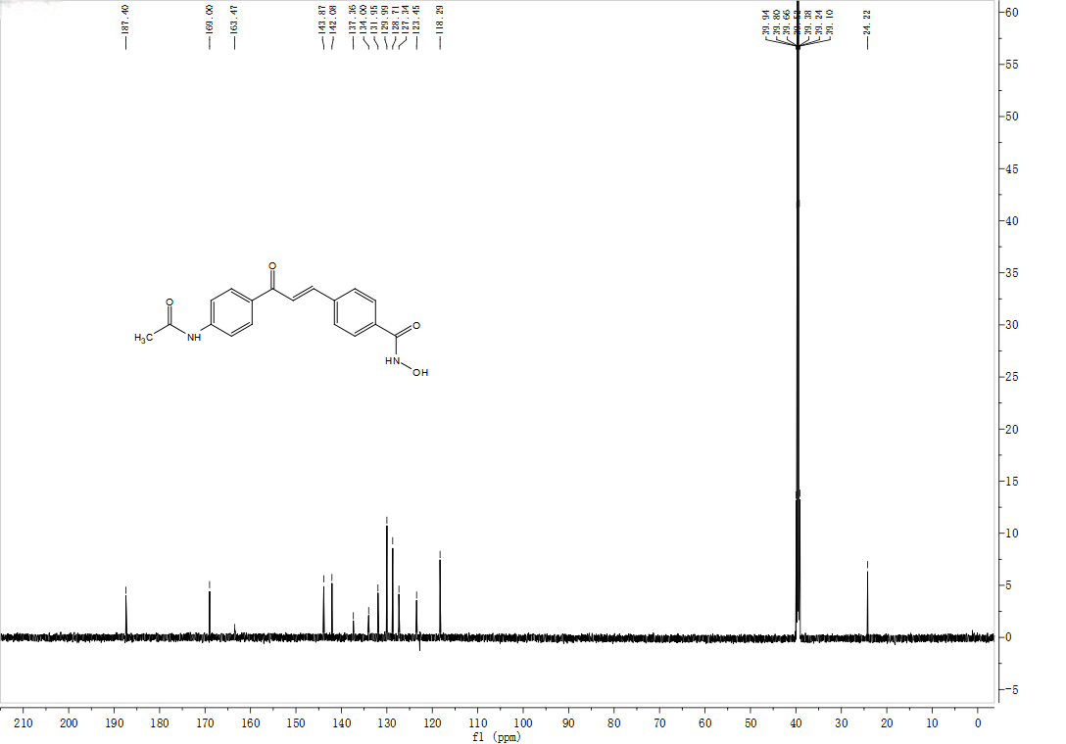
¹³C NMR (151 MHz, DMSO-d₆) spectra of 3r

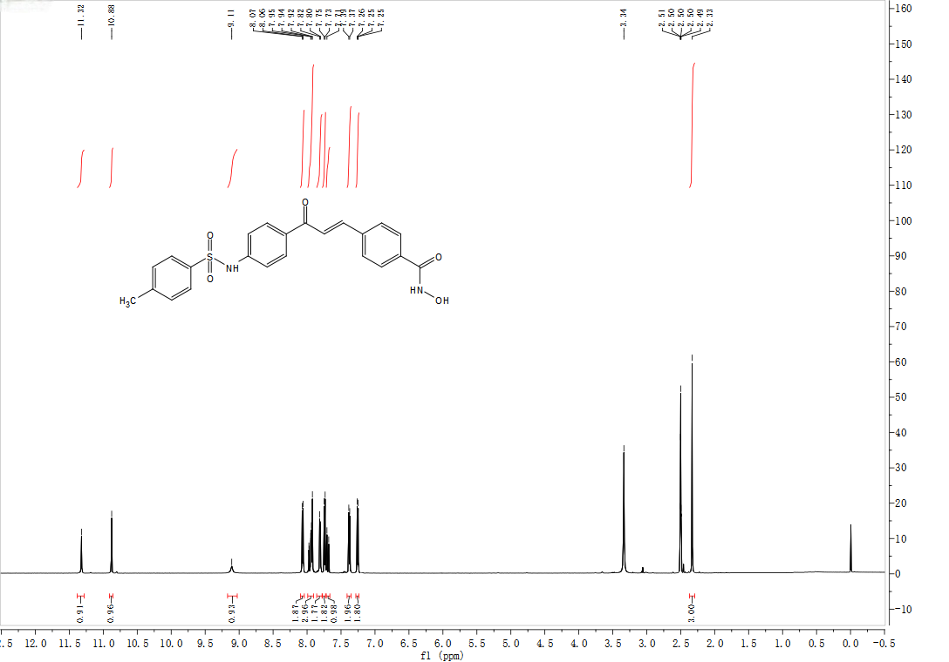
¹H NMR (600 MHz, DMSO-d₆) spectra of 3s
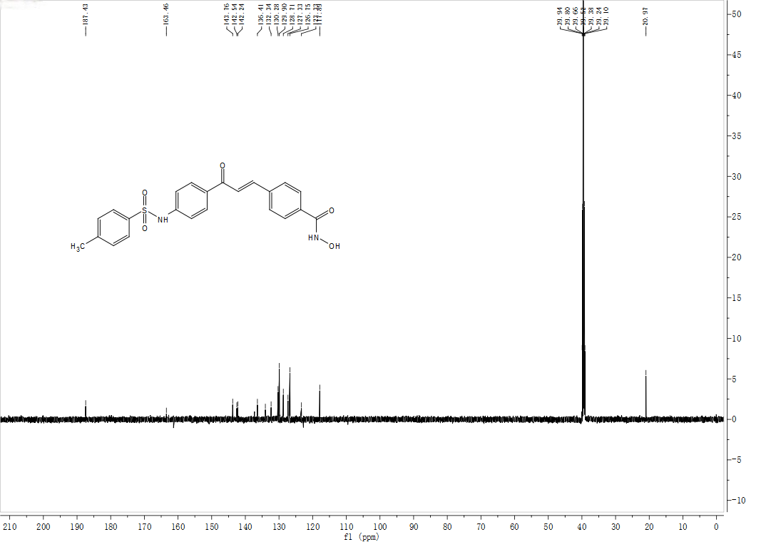
¹³C NMR (151 MHz, DMSO-d₆) spectra of 3s

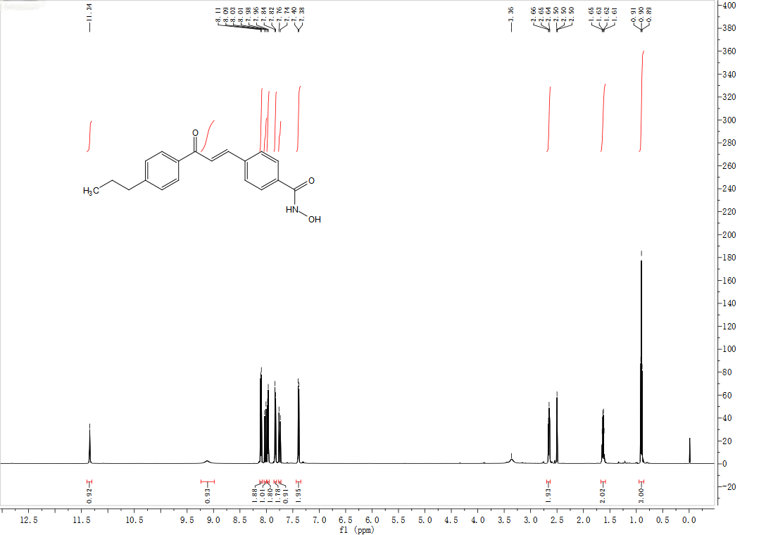
¹H NMR (600 MHz, DMSO-d₆) spectra of 3t
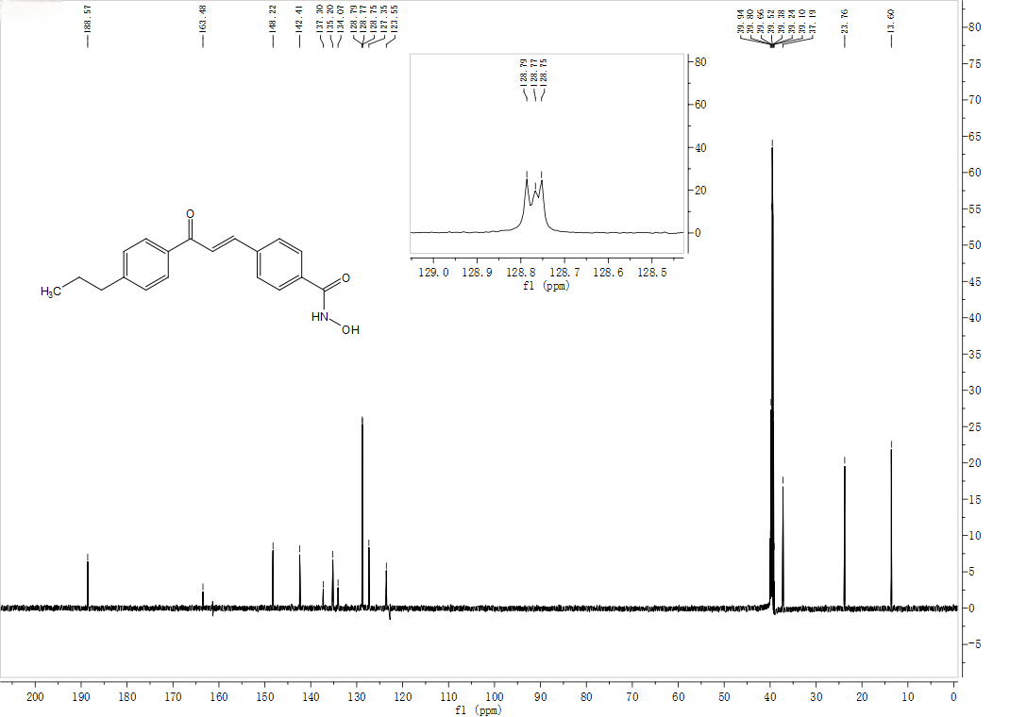
¹³C NMR (151 MHz, DMSO-d₆) spectra of 3t

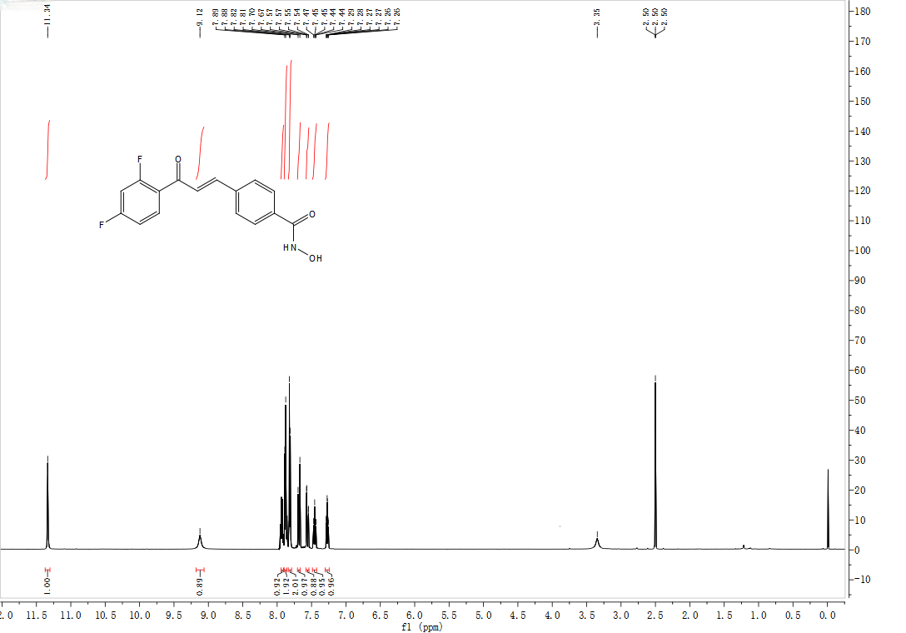¹H NMR (600 MHz, DMSO-d₆) spectra of 3u
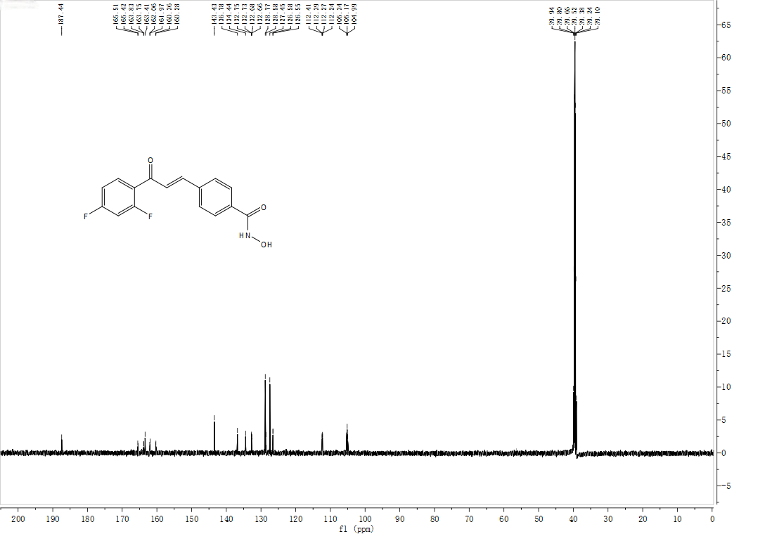
¹³C NMR (151 MHz, DMSO-d₆) spectra of 3u

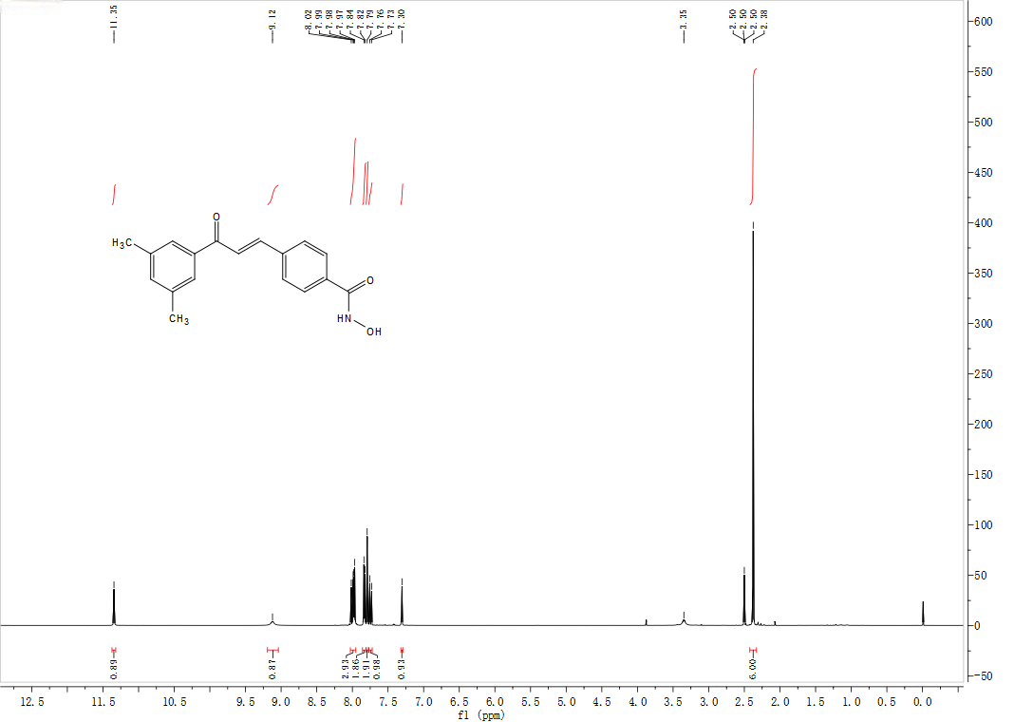
¹H NMR (600 MHz, DMSO-d₆) spectra of 3v
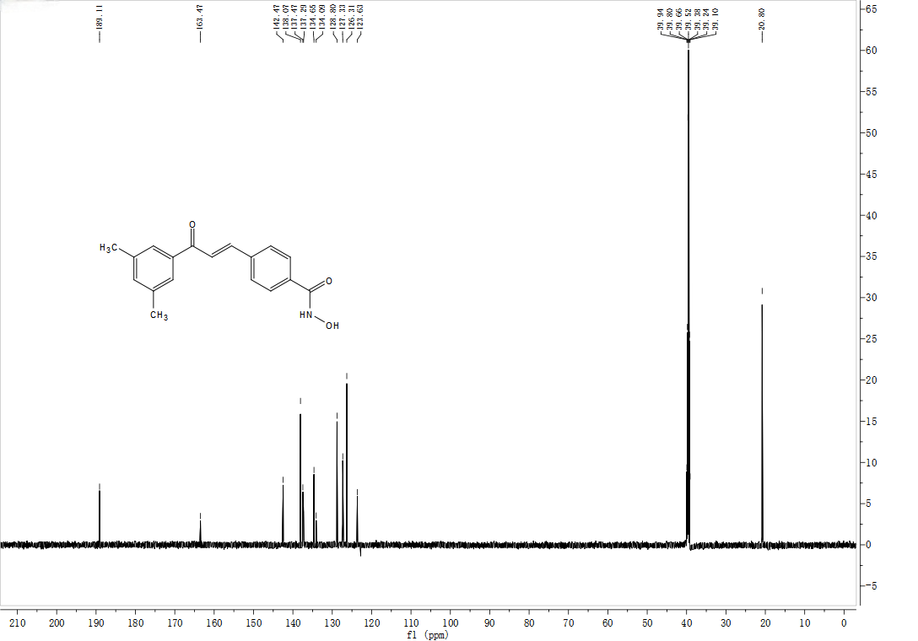
¹³C NMR (151 MHz, DMSO-d₆) spectra of 3v

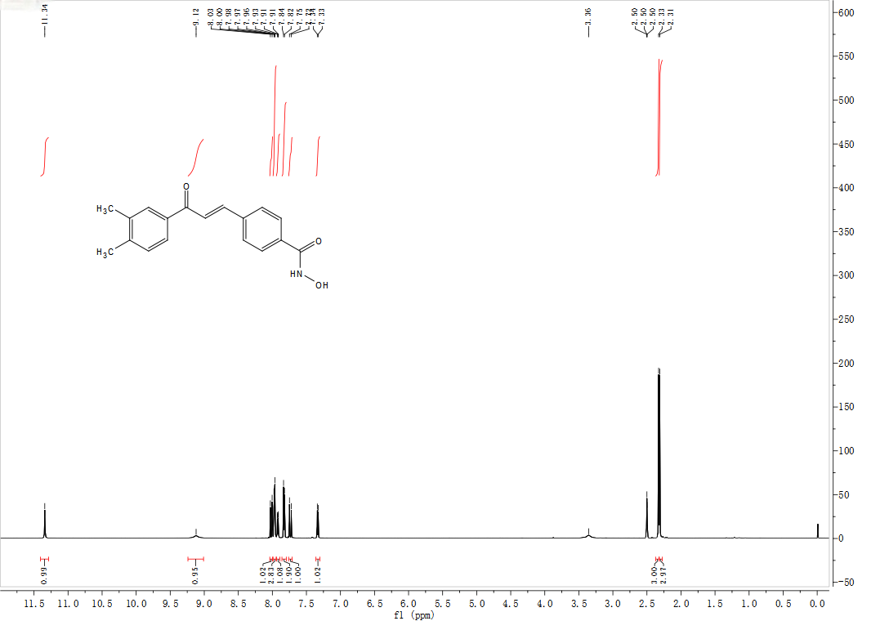
¹H NMR (600 MHz, DMSO-d₆) spectra of 3w
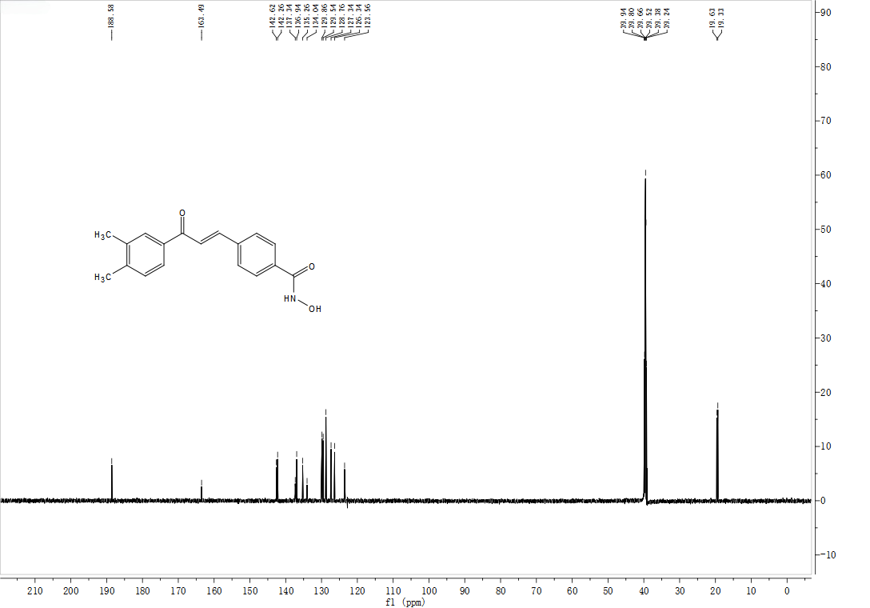
¹³C NMR (151 MHz, DMSO-d₆) spectra of 3w

